**Department of Computer Science and Engineering (CSE)**

**Faculty of Sciences and Engineering**

**Semester: (Spring, Year:2021), B.Sc. in CSE (Day/Eve)**

**Course Title: Data Structure Lab**

**Course Code: CSE 106 Section: DB211**

**Lab Project Name: Food Odering System**

**Student Details**

|  |  |  |
| --- | --- | --- |
|  | **Name** | **ID** |
| **1.** | **MD YEASIN ARAFAT** | **211002121** |

**[For Teachers use only: Don’t Write Anything inside this box]**

|  |
| --- |
| **Lab Project Status**  **Marks: ………………………………… Signature: .....................**  **Comments: .............................................. Date: ..............................** |

Table of Contents

Chapter 1 Introduction

1.1 Introduction

1.2 Design Goals/Objective3

Chapter 2 Design/Development/Implementation of the Project

2.1 Strucute

2.2 Methods: Main function, Serve function, Order function, Display function

Chapter 3 Performance Evaluation

3.1 Simulation Environment/ Simulation Procedure

3.2 Results and Discussions

Chapter 4 Conclusion

4.1 Introduction

4.1 Practical Implications

4.2 Scope of Future Work

References

# Chapter 1 Introduction

## Introduction

How to order food by using C languge

## Design Goals/Objective

The main objective of the Online Food Ordering System is to manage the details of Item Category, Food, Delivery Address, Order, Shopping Cart.

The purpose of the project is to build an application program to reduce the manual work for managing the Item Category, Food, Customer.

To order food practically by using some C code methods.

If anyone develop this, one can make a software for their restaurant.

# Chapter 2

# Design/Development/Implementation of the Project

## Structure

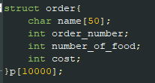

Figure 2.1: Structure

## Methods

## Main Function

## 

## Serve function

## 

## Order function

## \

## 

## Order

# Chapter 3 Performance Evaluation

## Results and Discussions

* + 1. **Results**

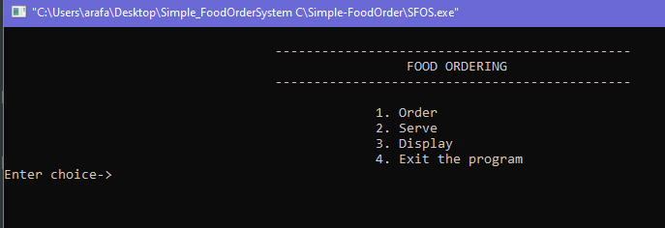

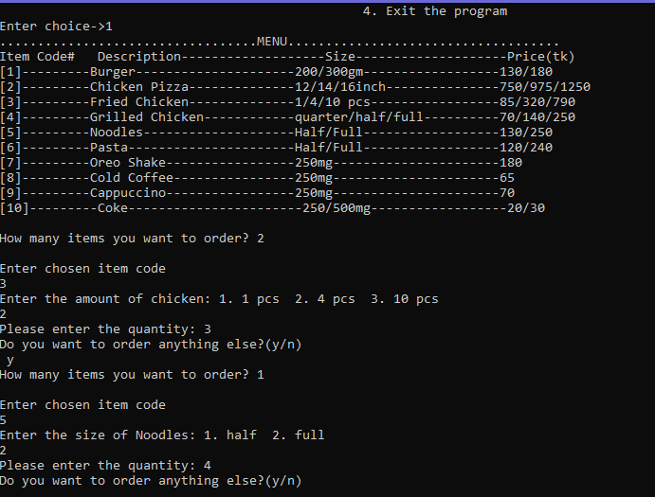

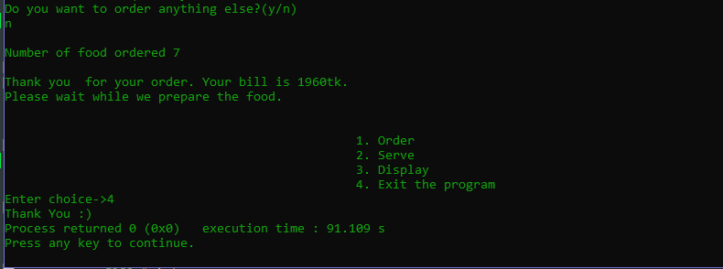

* + 1. **Analysis and Outcome**
* **Here, when we insert 1 it will get order option**
* **A menu card will be shown with different items**
* **Enter the choice item**
* **When we select item then enter the quantities**
* **Again, a message will come whether to get order ot not**
* **If no then get it the main menu**
* **Finally, when we enter 4 the console gives green color and exit from the program**

# 

# Chapter 4 Conclusion

## Introduction

Considering all above things, we made a short projet for food ordering system where in diffeent way we can order food by given some foods menu. The system does not create an external file to store the user’s data permanently. This system is developed using C Programming Language and different variables, strings have been used for the development of it. Food Order Management System in C Programming with source code is free to download. Use for educational purposes only! For the project demo, have a look at the video below.

## Practical Implications

By this project we can implement practically for ordering food. A Food Ordering Management System using C language is an easy project for beginners to learn how to build a web-based C language project.

## Scope of Future Work

The Scope of the project (Android / web panel based application) are as follows: Food Ordering app can sale Food product, preferred brands, kitchen needs, essential restaurant supplies and more, through this online, one- stop Food store.

# References

1. <https://www.programiz.com/c-programming>
2. <https://www.geeksforgeeks.org/c-programming-language/>